 BrightPond LED
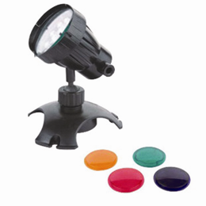

Model | Power Rating | Transformer Voltage | Transformer Hertz | Total Wattage | Cable  Mains | Cable  LV
PXBPL001 | 1 x 1w | 12v max 30VA | 50Hz | 1w | 2m | 8m
PXBPL002 | 2 x 1w | 12v max 30VA | 50Hz | 2w | 2m | 9m
PXBPL003 | 3 x 1w | 12v max 30VA | 50Hz | 3w | 2m | 11m
Waterproof Rating IPX8 (max depth 1.5M)

Introduction
Congratulations on the purchase of your PondXpert BrightPond LED garden pond light(s).
This unit is designed for outdoor use only. Please note that the unit’s transformer is weatherproof but should never be submerged in water.

General safety Instructions
Read and observe all of the instructions before installing, connecting and operating.
Make sure the lights are securely and correctly installed before switching on.
Always disconnect the lights when not in use and when carrying out maintenance.
Always disconnect all equipment in the pond before starting to handle, maintain, repair or install any pond equipment.
The appliance is not intended for use by persons (including children) with reduced physical, sensory or mental capabilities, or lack of experience and knowledge, unless they have been given supervision or instruction concerning use of the appliance by a responsible person. Children should be supervised to ensure that they do not play with the appliance.
For safety reasons, servicing or repair of this item should only be carried out by pondXpert.
Never hang or carry the pump by the power cord.
Do not operate the pump with a damaged cord or plug. The supply cord of the appliance cannot be replaced. If the electrical cord is damaged the product must be repaired by a specialist. There is a hazard of electrical shock!
Do not place a container, cup or any other object over the light. Water/ cool air must be allowed to circulate to stop the lights getting too hot.
The lights will become hot during operation and therefore must be handled with care.
Be careful to lay out the power supply cord and extension cords so they present no risk to anybody stumbling or pulling the cords.

Safety and Electrical Connections
The light set is electrically operated so great care must be taken during installation and operation. The following electrical and safety guidelines must be carefully followed.


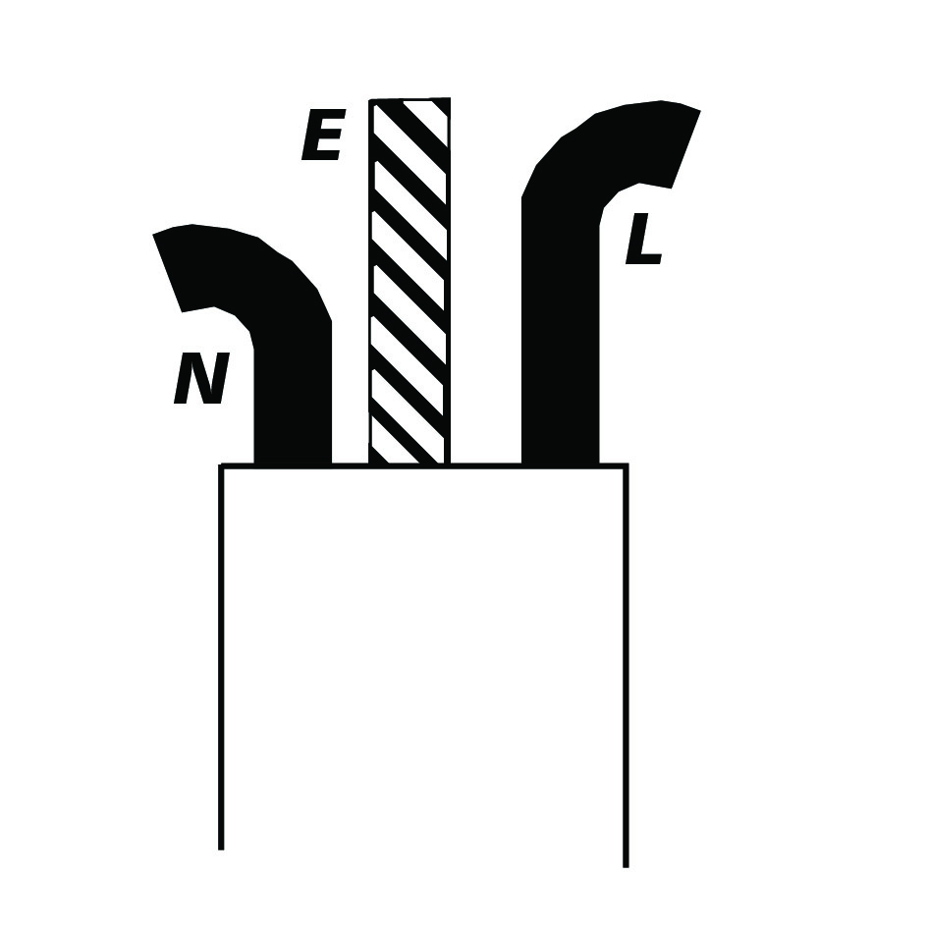
The wires in the mains electrical lead are coloured in accordance with the
following code:
BLUE – Neutral (marked with an “N” in most terminal connections)
BROWN – LIVE (marked with an “L” in most terminal connections)
GREEN/YELLOW – EARTH (marked “E” or in most terminal connections)
1st January 2005 revised Building Regulations for England and Wales
Installing this product in the garden is classified as ‘notifiable’. The Regulations now require you to tell your local authority building control department that you intend to install this product before installation. Your local authority will let you know how you can get your installation approved

The termination to the mains supply should be permanent, inside a dry weatherproof enclosure, through a double pole switched fused spur with a minimum contact gap of 3mm – (disconnected) to BS 3676 – and fitted with a 3 or 5 amp fuse.
Exposed cable runs should be sensibly positioned, and protected if necessary by armoured conduit. A 10mA or 30mA Residual Current Circuit Breaker (RCD) MUST be fitted to the mains supply. Permanent installations to the mains supply (hard wiring) must comply with the regulations of the local electricity authority which may stipulate the use of metal or plastic conduit to protect the cable. If in any doubt about wiring to the mains supply contact a qualified electrician or your local electricity authority.

Directions for use
These outdoor lights can be used in or out of the water.
If used out of water take care to make sure no objects touch or are left too close to the lights as they get extremely hot in use. When used submerged it is best to place the unit approx 1 foot below the water surface (at deeper levels brightness is reduced).

Changing the Bulb
Simply unscrew the light cap as shown on the light itself.
Remove the bulb by gently pulling it out of the electrical connection.
Insert a new bulb by pushing gently into the electrical connection.
Re-assemble the end cap by rotation.

Limited Warranty
This product is guaranteed for a period of 12 months from the date of purchase for material or manufacturing defects. The guarantee covers the substitution of defective parts. However, the guarantee is considered null and void in the case of improper use, improper handling or negligence on the part of the buyer. The bulbs are not guaranteed. If your pondXpert light fails please take it back to the retail outlet from where it was purchased. You will be required to take your receipt/proof of purchase with you.

Your appliance contains valuable materials which can be recovered or recycled. Leave it at a local civic waste collection point.
This does not affect your statutory rights.
PondXpert
A3 Bentley Avenue
Billingham
TS23 4BU
UK 01642 370898 www.pondxpert.co.uk

